F74056247曾大瑋

Project2-Edge Detection

原始程式碼

import cv2

import numpy as np

from matplotlib import pyplot as plt

antOrigin = cv2.imread('ant.png',0)

planeOrigin=cv2.imread('plane.png',0)

#Utility function to show image in grayscale

def showImage(image,text):

plt.subplot(111)

plt.imshow(image,cmap='gray')

plt.title(text)

plt.xticks([]), plt.yticks([])

plt.show()

#Show origin image

def showOrigin(image):

showImage(image,'Original Image(grayscale)')

#Show Gaussian Blurred image

def showGaussian(image):

image=cv2.GaussianBlur(image,(5,5),0) #(5,5) means 5*5 pixel into 1 pixel blurred

showImage(image,'Gaussian Blurred Image(grayscale)')

#Show Equalized Histogram image

def showEqualizeHist(image):

image=cv2.GaussianBlur(image,(5,5),0)

image=cv2.equalizeHist(image)

showImage(image,'Equalized Histogram Image(grayscale)')

#Show Sobel operator filtered image

def showSobel(image):

image=cv2.GaussianBlur(image,(5,5),0)

# get sobel image in X and Y derivation

sobelX=cv2.Sobel(image,-1,1,0,ksize=3) #2-nd derivation sobel operator

sobelY=cv2.Sobel(image,-1,0,1,ksize=3)

#get abs of image

sobelX = cv2.convertScaleAbs(sobelX)

sobelY = cv2.convertScaleAbs(sobelY)

#combine image together

image = cv2.addWeighted(sobelX, 1, sobelY, 1, 0)

showImage(image,'Edge Image')

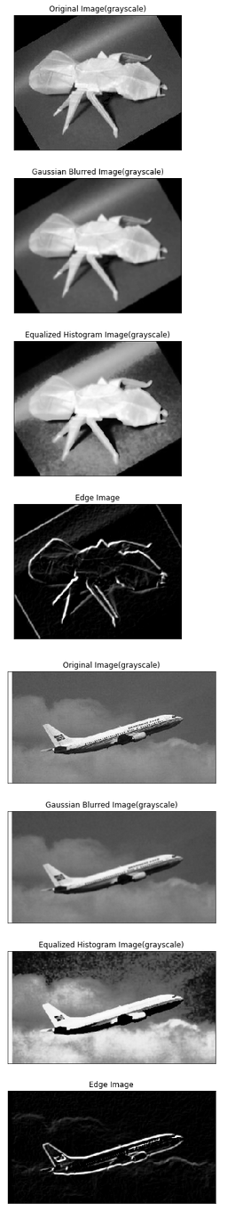showOrigin(antOrigin)

showGaussian(antOrigin)

showEqualizeHist(antOrigin)

showSobel(antOrigin)

showOrigin(planeOrigin)

showGaussian(planeOrigin)

showEqualizeHist(planeOrigin)

showSobel(planeOrigin)

程式碼解說

有5個function

其中 showImage(image,text):為顯示圖片function

剩下的為處理圖片

showGaussian(image): 將圖片做高斯模糊

showEqualizeHist(image): 將圖片做Euqalized histogram

showSobel(image): 將圖片做Sobel operator filter

showOrigin(image): 顯示原始圖片

輸出結果

如範例圖